NE381 – Design & Implement AD Network

LAB 1:  
Server 2019 & Windows 10 Client Setup

* **Part 1: Objective** – Begin building an Active Directory network with two domain controllers and two clients. These steps ensure a smooth installation of Active Directory in Week 2.

In this lab we’ll:

* + Create Administrator account with password.
  + Set Time zone
  + Set Network & IP address
  + Connect to Internet & System Updates
  + Install Chrome
  + Change Folder View Options
  + Personal Administration Account
  + Firewall Control
  + Ping between

**Important Note!**: There are Two distinct networks already configured within Skytap; 192.168.1.0/24 and 10.0.0.0/24. You will setup DC1 & CLIENT1 within 192.168… and DC2 & CLIENT2 within 10.0… Please Read VERY Carefully & Pay Attention!

1. Logon to Canvas – Course Modules -> Week 1 -> click **NE381 - Create Skytap Environment**. Be patient while your personal environments are created.  
   **Important!** Once the environments are created, copy the URL of the resulting Skytap page and Email it to yourself with Subject of: **NE381 -> Skytap Environment**. Use that link for the rest of the quarter.
2. From the Skytap environment page click DC1 and then click the Play button to start the VM  
   
3. When you get to the ‘Hi there’ screen proceed by pressing Next.

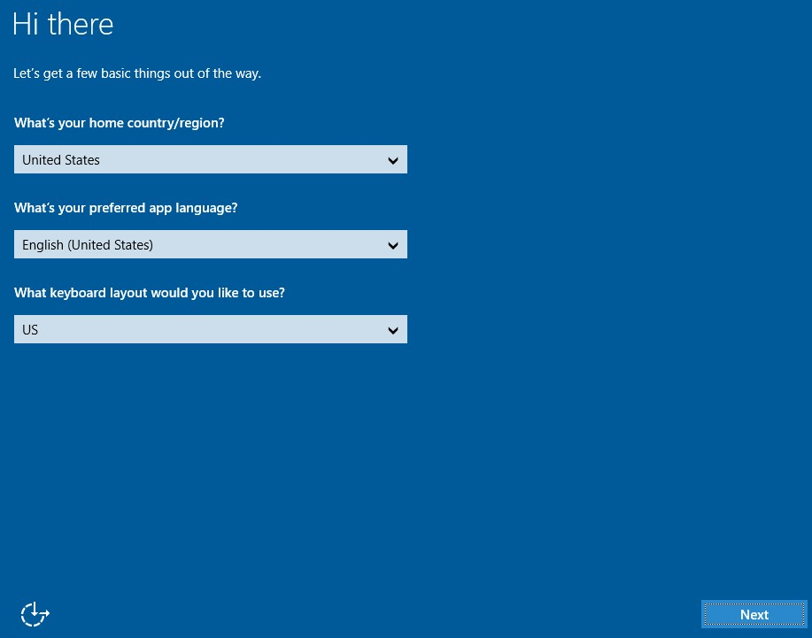

1. If prompted for a license key enter:  
   **DGC3V-FNHQY-FHTXT-HYFJ7-FJR67**
2. [Accept] the License Terms
3. When prompted for a password enter **Password19** then click finish
4. Log on to the server using the newly created credentials.

**\*It may take it a few minutes to create the profile and load the desktop, be patient.**

1. Server Manager -> Tools menu -> Services, **stop and disable the Windows Update service.**
2. Server Manager -> Local Server -> Time Zone: Change to **[UTC-05:00 Eastern Time…]**
3. Server Manager -> Local Server **Change your computer name to DC1** restart the server.

|  |
| --- |
| Once rebooted, log on, open the **Server Manager** then **paste a screenshot** the name of the server below: |

1. DC1 server is in the 192.168.1.0/24 network with a gateway of 192.168.1.1 and a DNS server of 1.1.1.1 but is not configured.  
   Assign the DC1 server (TCP/IPv4) an IP address:  
   IP Address: **192.168.1.10**Subnet: **255.255.255.**0  
   Default Gateway: **192.168.1.1**  
   Preferred DNS: **1.1.1.1**

|  |
| --- |
| Screenshot DC1 IP settings: |

1. Allow the PC to be Discoverable on network, click [YES].  
   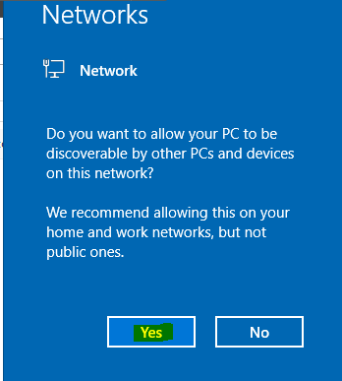
2. Open CMD prompt and ensure you can **ping google.com**If not, get it fixed before continuing. You **Must** be able to connect to the internet and the DNS server must respond.
3. Server Manager -> Local Server -> IE Enhanced Security Configuration -> **Off** for Administrators & Users.
4. Launch IE and use it to **Install Google Chrome**
5. Close Internet Explorer and Server Manager
6. Open a **Windows Explorer Folder**
7. Click the View tab -> Options -> Change Folder and Search Options.
8. Click on the View Tab in Folder Options.  
   Select  
   (*) show hidden files, folders or drives  
   [ ] Hide empty drives  
   [ ] Hide extensions for known file types  
   [ ] Hide folder merge conflicts  
   [ ] Hide protected operating system files.  
   Click [Yes] on any pop-up Warning.

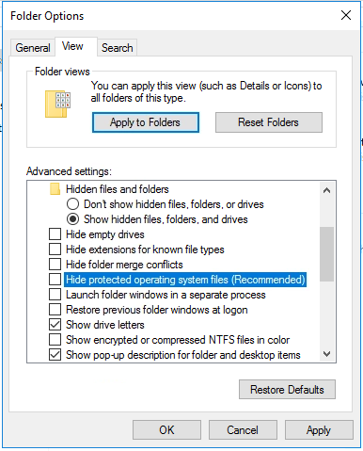

1. Now, create yourself a new Personal L**ocal Administrator (PLA) account using your First Initial and Last Name (Ex: JSmith).**   
   User **Password19** and set the password to never expire.  
   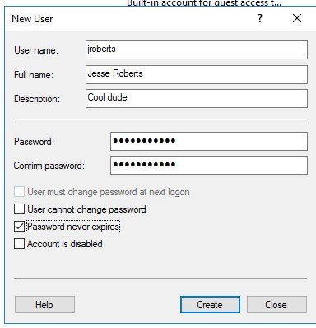

|  |
| --- |
| Screenshot user account dialog box: |

1. **Make this new account a member of the Administrators group.**
2. Logout of the server
3. Login with your new Personal Local Admin (PLA) account.
4. [Security Step]  
   Next, we will configure the system so that the last logon name is not displayed. You may have noticed that usernames were being displayed in the left-hand corner on your last logon. Displaying login names can be considered a security issue for most organizations.

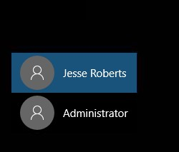

1. From Server Manager -> Tools -> **Local Security Policy**
2. Expand to the following area: Security Settings -> Local Policies -> Security Options

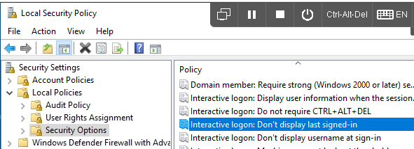

1. Find Interactive logon: Don’t display last signed-in -> Enabled.

|  |
| --- |
| Screenshot : |

1. Use the Control Panel to **turn off the Windows Firewall.**
2. Sign out of DC1.
3. **Sign into DC2 as Administrator : Password19**
4. **Now, Repeat ALL above steps for DC2.**
5. **Stop & disable Windows Update service**
6. **Change time zone to [UTC -05:00 Eastern Time]**
7. **Rename to DC2.**
8. DC2 is in the 10.0.0.0/24 network with a gateway of

10.0.0.254 and a DNS server of 1.1.1.1 but is not configured.

Assign DC2 an IP (TCP/IPv4) address:  
IP Address: **10.0.0.20**

Subnet: **255.255.255.0**Default Gateway: **10.0.0.254**  
Preferred DNS: **1.1.1.1**

|  |
| --- |
| Screenshot DC2 IP settings: |

Open CMD prompt and ensure you can **ping google.com**If not, get it fixed before continuing. You **Must** be able to connect to the internet and the DNS server must respond.

Be absolutely sure you have **completed ALL** of the previous steps as done on DC1, including the firewall.

Leave DC1 & DC2 running and proceed to Part 2

# Part 2 – Objective: Get Client (Windows 10) machine running, create user accounts, rename systems, set IP’s and test connectivity between the servers.

1. Power on CLIENT1
2. Sign-in as **Student** with a password of **Password10**
3. Control Panel→ System and Security→ System to rename the computer to **CLIENT1**.
4. Restart the Client1 and login. Open Command Prompt
5. Type **hostname**

|  |
| --- |
| Screenshot the command prompt output: |

1. Update your IP address settings to be statically assigned This client is in the 192.168.1.0/24 network with a gateway of 192.168.1.1 and a DNS server of 8.8.8.8  
   Assign the CLIENT1 server an IP address:  
   **192.168.1.11  
   255.255.255.**0 Subnet  
   **192.168.1.1** Default Gateway  
   **8.8.8.8** Preferred DNS

|  |
| --- |
| Command prompt ‘*ipconfig*’ screenshot: |

If prompted to allow PC to be discoverable on network, click [Yes]  


1. Open CMD prompt and ensure you can **ping google.com**If you cannot ping google.com, fix your network settings, then continue.
2. Use IE to install Google Chrome.
3. Pin File Explorer to the Taskbar  
   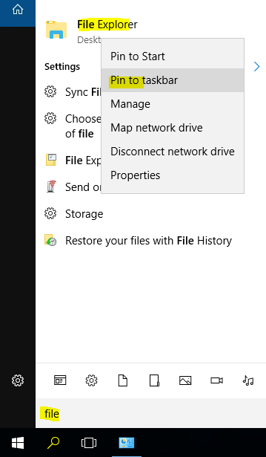
4. From the Control Panel, **Turn off the Windows Firewall**
5. Set your Folder View option to the same as DC1&2.
6. **Repeat ALL of the above steps for CLIENT2.**  
   Set machine name to **CLIENT2.**

CLIENT2 is in the 10.0.0.0/24 network with a gateway of

10.0.0.254 and a DNS server of 8.8.8.8

Assign the CLIENT2 server an IP address:  
**10.0.0.21  
255.255.255.**0 Subnet  
**10.0.0.254** Default Gateway  
**8.8.8.8** Preferred DNS

|  |
| --- |
| Screenshot: |

1. At this point All four systems are configured to access the internet and each other. Firewalls are off, right??
2. **From each machine**, open CMD prompts and type **hostname** then **ping** their corresponding Client / Server IP addresses. DC1 should ping the IP of CLIENT1 and DC2 should ping the IP of CLIENT2, and vice versa.  
   **Note:** Because DNS is not fully configured you cannot ping by name yet, only IP address for now.  
   Be sure to use the **hostname** command first!  
   Screenshot:

|  |  |
| --- | --- |
| Ping DC1->CLIENT1 | Ping DC2->CLIENT2 |
| Ping CLIENT1->DC1 | Ping CLIENT2->DC2 |

**Do Not Use the Skytap menu to Shut the systems down!!**

1. Once your sure of good communications between the Clients & Servers. **Shutdown the machines using ONLY Start Menu -> Shutdown.**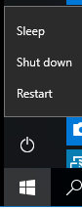

End Lab 1.

Please save this file and submit to Week 1 -> Lab 1.